BANNER IMAGE:

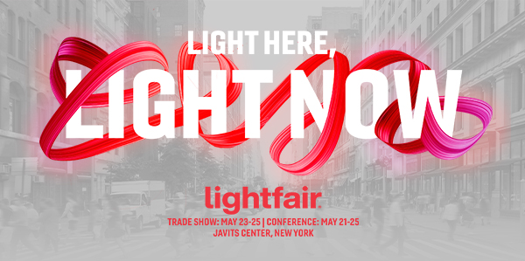

HEADLINE:

Join Us at the Year’s Most Electric Show

COPY:
Dear <Name>,

Experience a bolder, brighter LightFair when the nation’s largest lighting event takes over Manhattan this spring. This is where everyone in the industry can:

- Form profitable partnerships and collaborate with luminaries in the field.
- Discover the latest innovations on the vibrant show floor.
- Draw inspiration through experiential tours and integrated events with NYCxDESIGN.

<Insert company name> will be at booth #XXXX and launch new products like <product>, <product>, and <product>.

LightFair 2023
Trade Show: May 23-25 | Conference: May 21-25
Javits Center, New York

We look forward to seeing you at LightFair 2023.

<insert your name/company’s name>

CTA:
Get more information and register at lightfair.com.

